March 14, 2019

R Markdown and Interactive Dashboards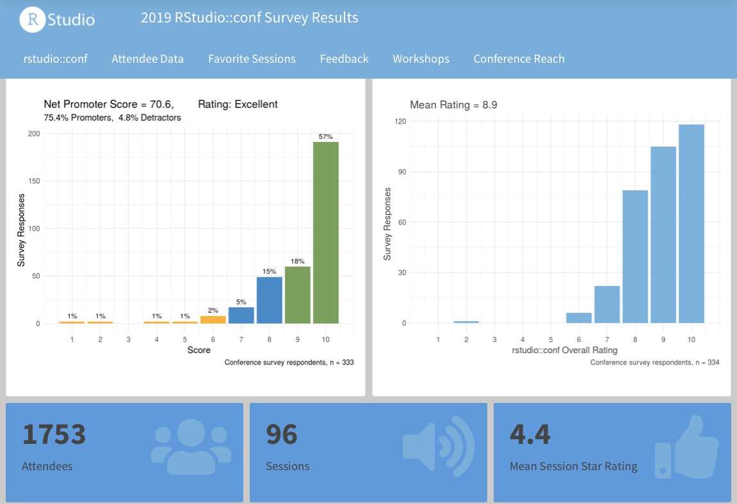

## Audience

This workshop is intended for R users who wish to reach a broader audience through analytical reports and interactive dashboards.

## Overview

This one-day introductory workshop will teach students the fundamentals how to create R Markdown scripts for reports and interactive applications. Attendees will learn how to:

* Design R Markdown for reproducibility and reuse.
* Craft their own R Markdown reports.
* Parameterize R Markdown content for personalized report generation
* Publish R Markdown content to other servers such as RStudio Connect and RPubs.
* Add flexdashboard interactive elements and pages to R Markdown documents
* Combine interactive elements with static content to create dynamic dashboards
* How to add Shiny interactivity to your dashboard when you need it.
* Design interactive applications for best performance

In the course of this day, students will gain experience constructing several reports and dashboards from data sets provided to the class. We'll also touch on what students would need to deploy such applications within their own organizations

## Outline

1. R Markdown: One Language, Many Output Products
2. Markdown Basics
   1. Basic Syntax
   2. Knitting
   3. Chunks
   4. Languages
   5. Tables
3. R Markdown Output Types
   1. Reports
   2. Slides
   3. Blogs
   4. Books
4. Publishing R Markdown Documents
   1. Parameterization
   2. One-button publishing
   3. Scheduled execution
   4. Automated email reports
5. Interactive Dashboards: Bringing Your Analyses To Life
   1. Flexdashboards
      1. Layouts and Design
      2. Interactive parameters
   2. HTML Widgets
   3. Storyboards
6. Shiny interactivity within R Markdown

## Prerequisites

We recommend that attendees have basic skills in R, ggplot2, and the tidyverse so that they can create content for their reports and dashboards. Should students not have that experience, we will provide simple examples hat those users can copy, but they should recognize that they find some topics difficult to understand.

We recommend that students have R, the RStudio IDE, and tidyverse software installed prior to arriving at the workshop. Those who do not wish to install software on their computers should create free RStudio.cloud accounts before they arrive. Anyone using RStudio.cloud will require the use of an approved browser such as Apple Safari or Google Chrome.

## Presenter Bio

Carl is the Director of Education at RStudio and has been a dedicated R user since 2002. Carl leads a team of professional educators and data scientists at RStudio whose mission to train the next million R users globally. Carl regularly teaches workshops on topics such as reproducible R Markdown and RStudio's Pro products to help R beginners become productive more quickly. Carl lives with his wife Carolyn in Stow, Massachusetts at the pleasure of his two cats.